Run: “make” (receive output file, use output file name and type “./[name]”

then: “make clean” to clear output file
for example:

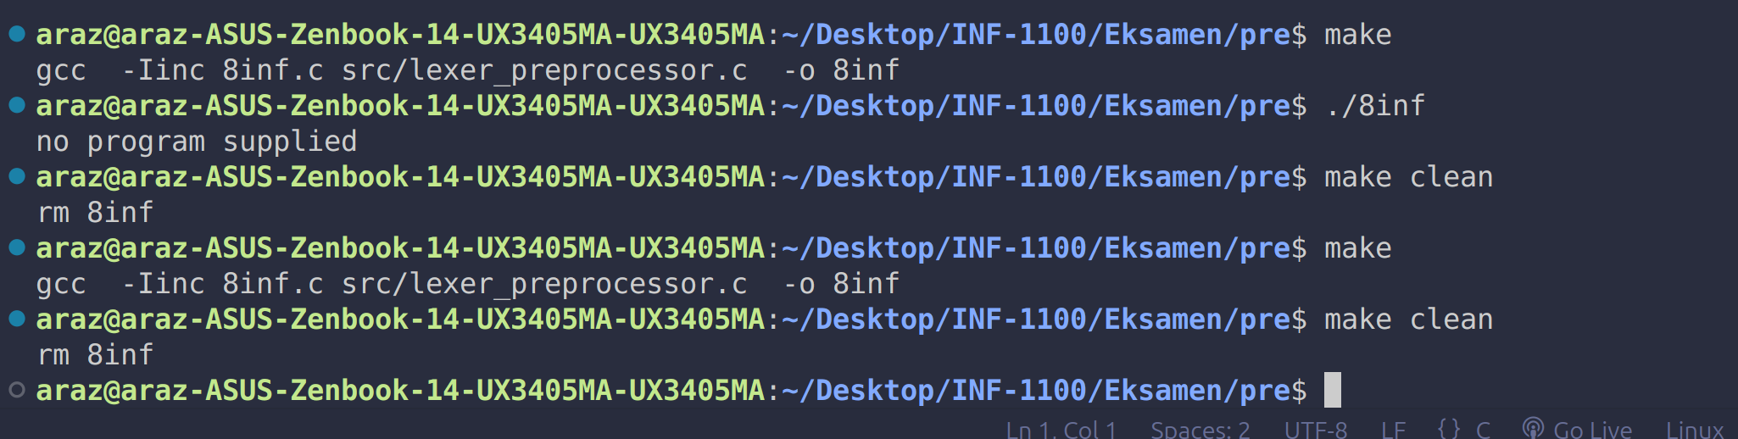
TO YOURSELF: IF you add something new to make make sure to fix accordingly to run make again otherwise you’ll run into errors and not able to run your make file!
Case: Inappropriate Directory
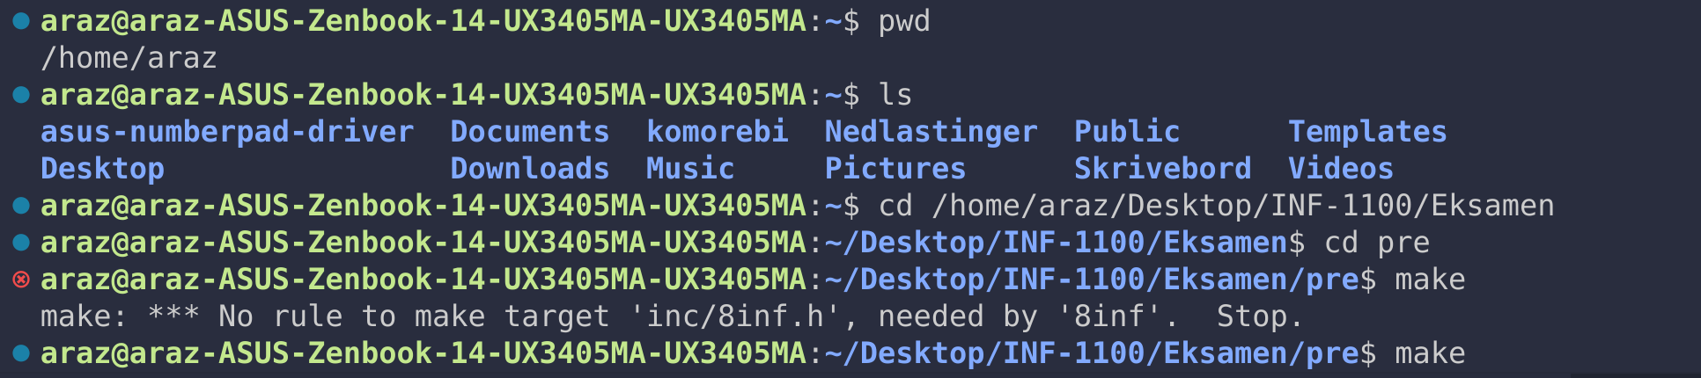
pwd: print working directory

ls : Shows all folders and files in your current file
cd [target] : changes directory you are in

